Andre Hardy – Project 6-3

16. review the digests generated. If necessary, expand the size of the window. What can you say about these digests? compare Md2 with sha512. What makes sha512 better than Md2? Why?
A: The digest length makes SHA512 better as it is significantly less susceptible.
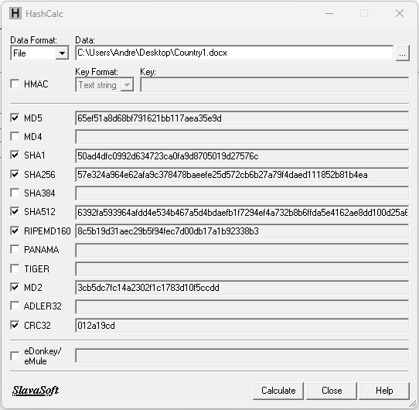

21. This file is the same as the previous except a single period was removed. are the digests different? What does this tell you about hashing digests?
A: Yes, the digests are different because hashing digests are unique down to the character of its contents, including a period.
